ASR

Request an additional column  “Shipping Details” as per file under column AC to be added into EO entry.

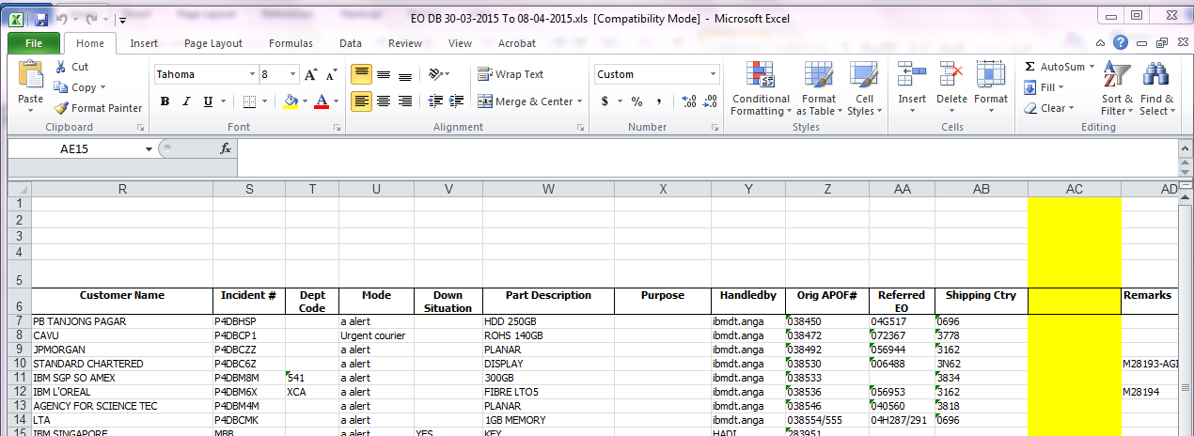

WMS update:

New column:

SCH_EO.ShippingDetail ( varchar 250)

